**Video Encoder Instruction**

**Introduce**

Encoder is a device that converts video signal into RTSP / RTMP / HTTP / HLS / UDP / RTP / SRT protocol network video signal, which is widely used in education, monitoring, conference, celebration, radio and television, entertainment and other fields.

**Parameter**

|  |  |  |  |  |
| --- | --- | --- | --- | --- |
| Name | IP | Power Supply | Temperature | Humidity |
| Encoder | 192.168.1.168 | 12V 2A | -20℃+60℃ | <90%, non-condened |

**Ope WEB**

Connect the power supply, network and signal source of the encoder. Open the web with a browser and enter http://192.168.1.168 (Username:admin password:admin).

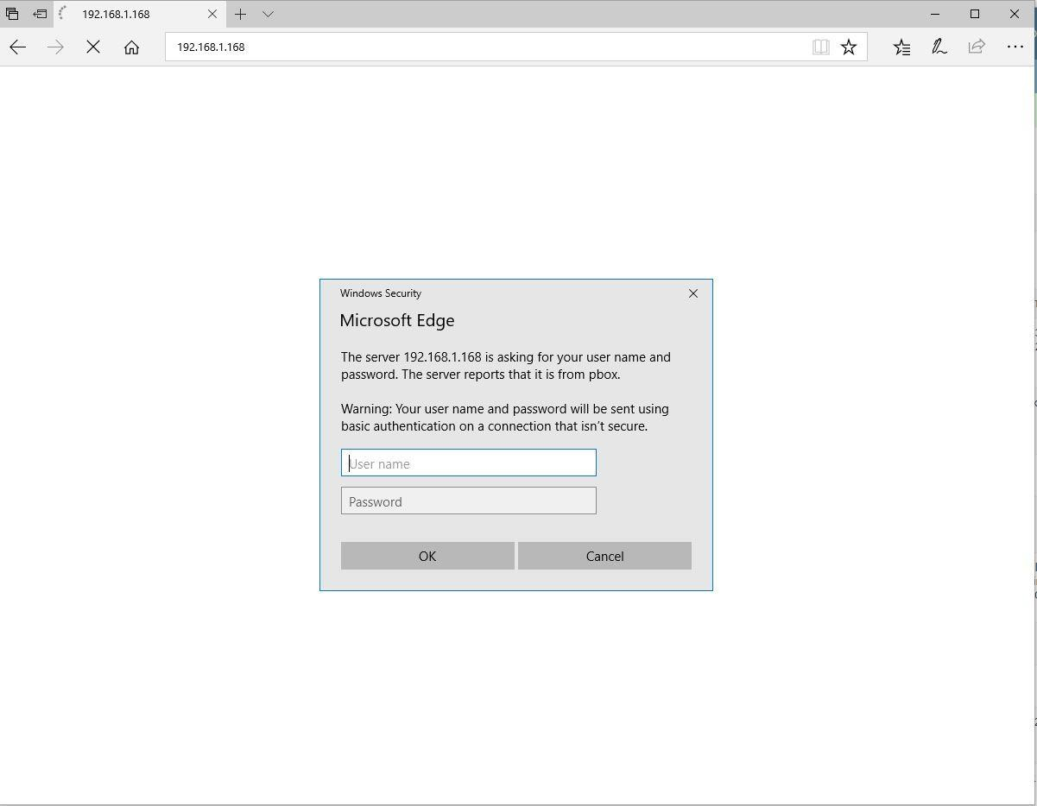

If the browser can't open the web, you need‘ scandev ’tool to modify the device IP .



**Play video**

1. Status→Main stream→Copy TS URL or RTSP URL,download VLC media player, Playing TS or RTSP in VLC.

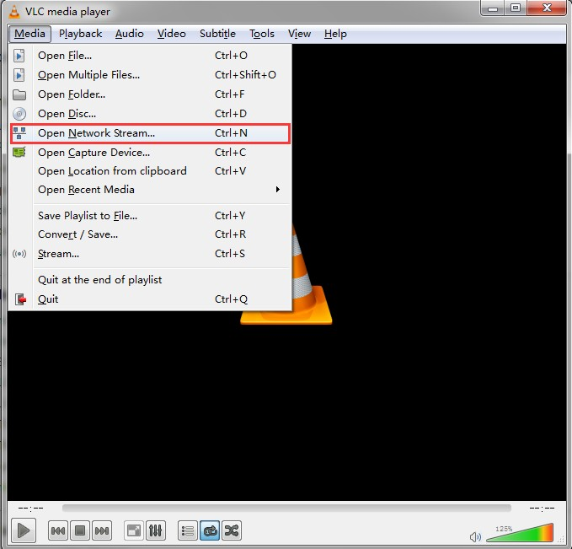

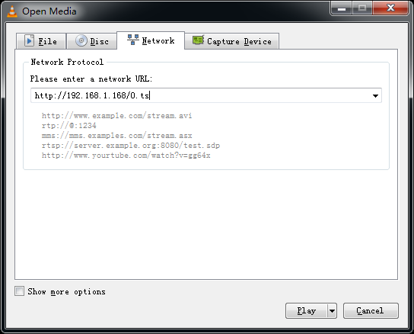

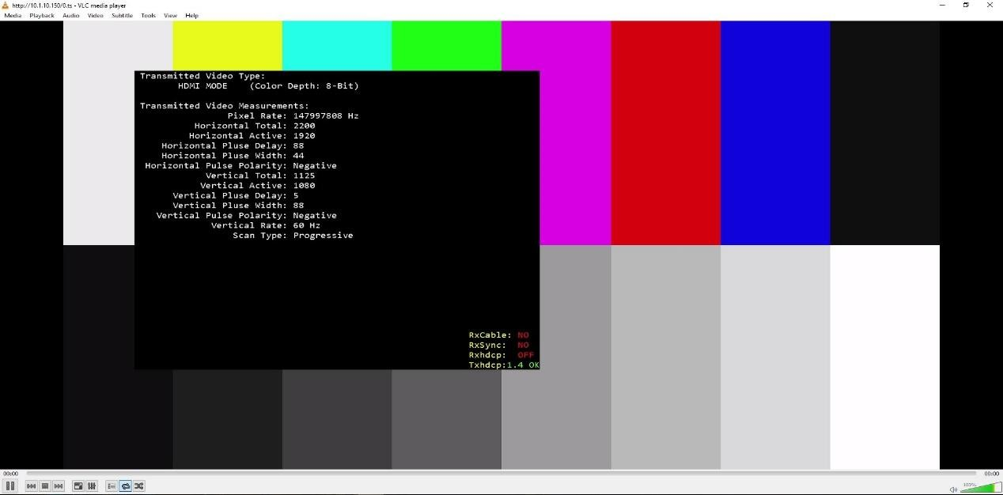

**Live**

1. Fill RTMP PUSH URL into main stream→ RTMP(S)/RTSP→Enable.

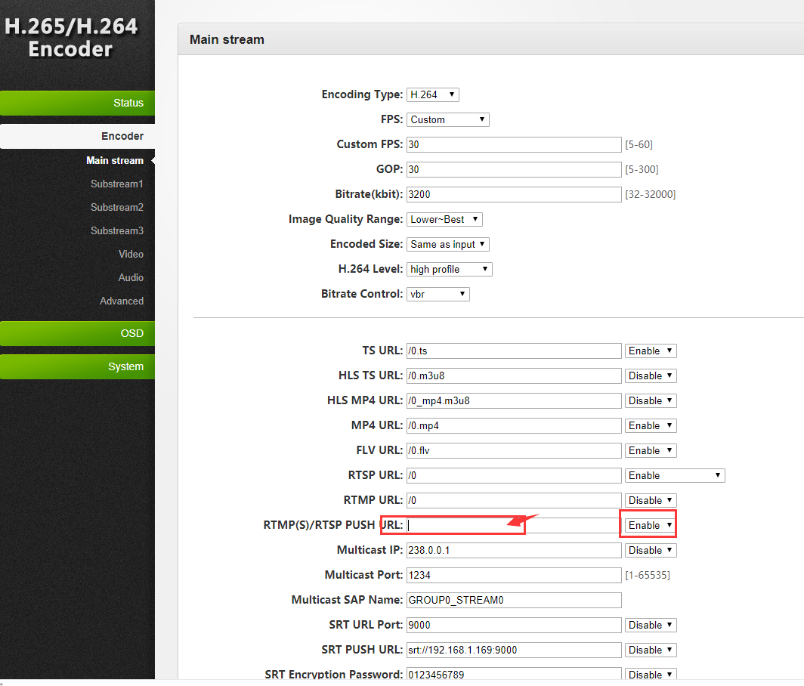

1. Main stream → encoding type → H.264 →Apply→Reboot the encoder.

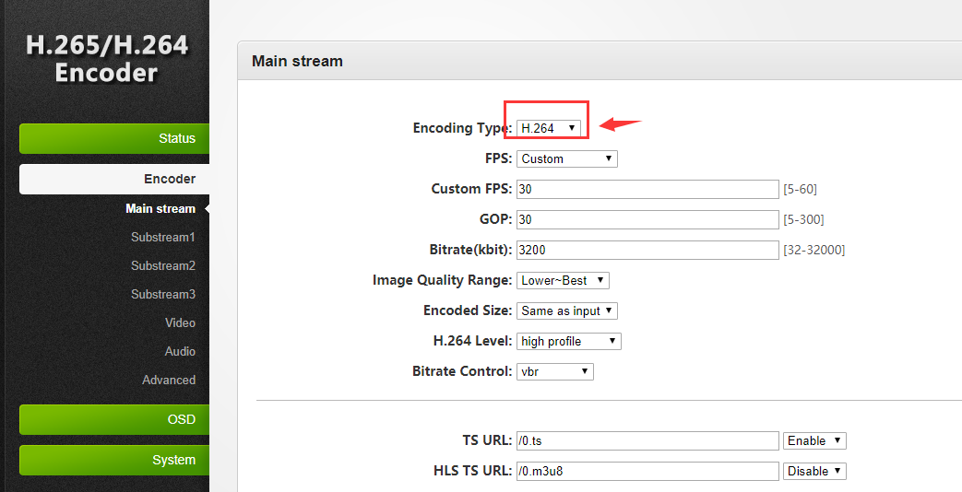

3.Status→ Main stream → Whether the RTMP PUSH URL is connected.

**Multicast**

1. Encoder→Main stream→Multicast IP →Enable→Apply.

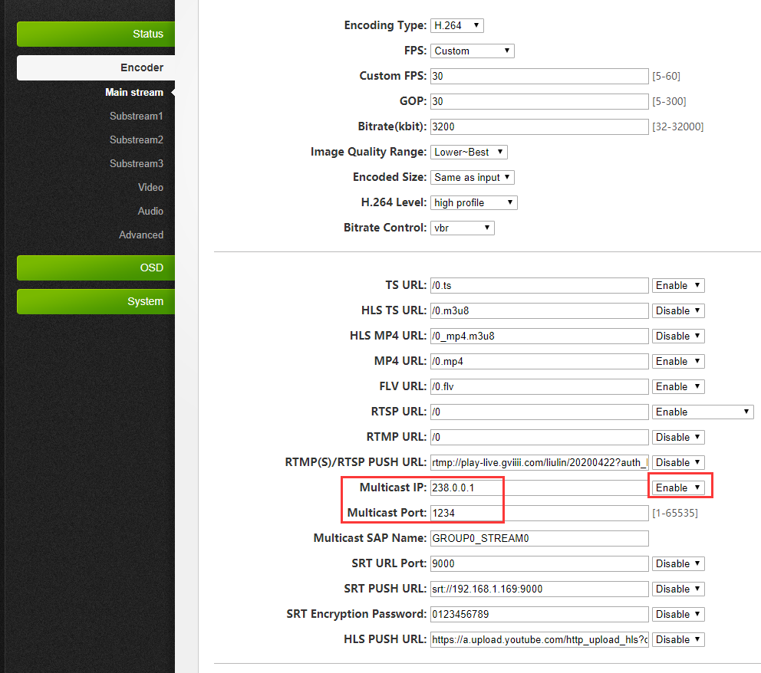

2.Status→Main stream→Playing Multicast URL in VLC.

Realize the simultaneous access of multiple clients in LAN.

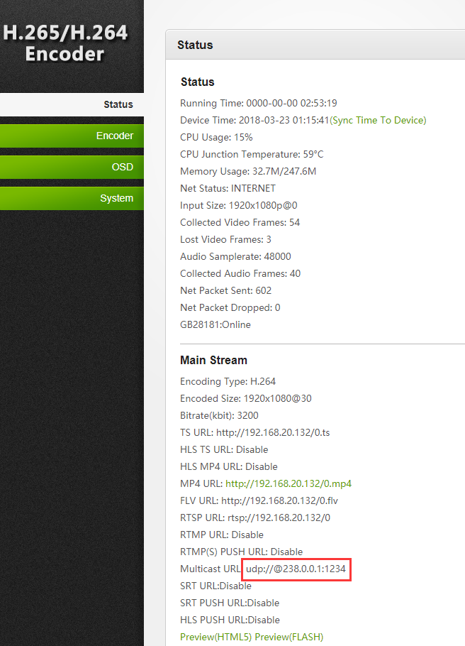

**NVR**

1. Encoder→Main stream→RTSP URL→Enable→Apply.

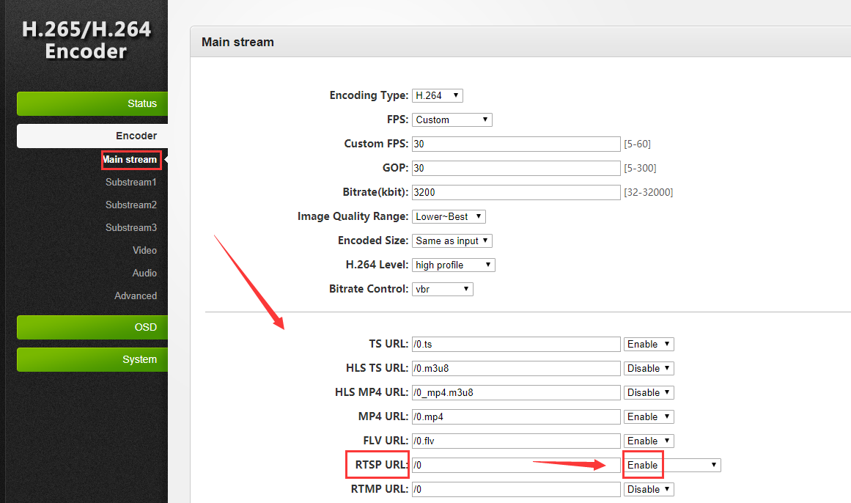

### 2.Encoder→Substream1→RTSP URL→Enable→Apply→Restart the encoder.

**Mshow**

1. Encoder→Main stream→RTSP URL→Enable→Apply.



2.Encoder→Advanced→VMIX Compatible →Enable→Restart the encoder.

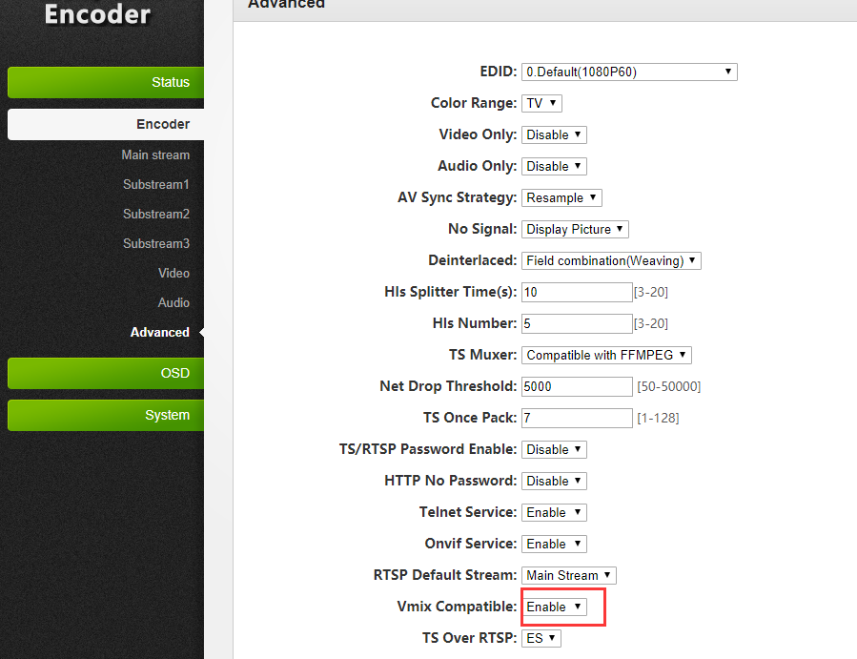

**SRT**

1. Encoder→Main stream→SRT URL Port→Input port→Enable→Apply.SRT Encryption Password→Input password→Enable；SRT Encryption Password is not required.

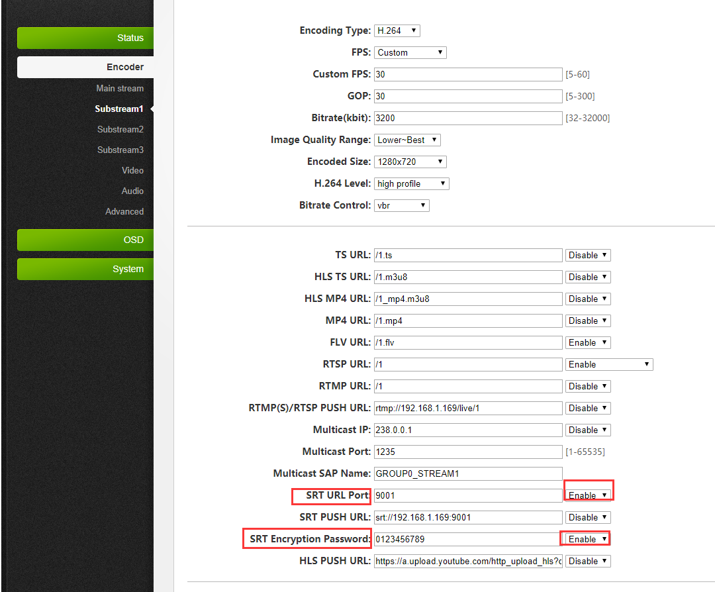

2. Status→Main stream→Playing SRT in VLC。

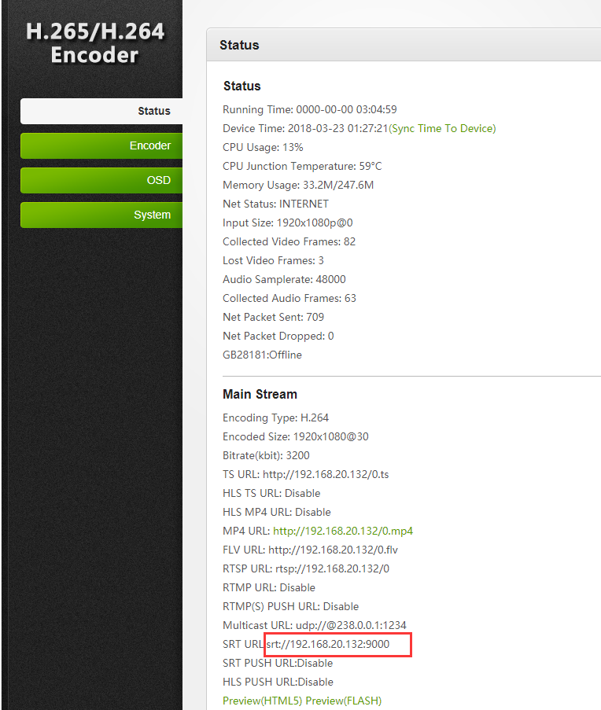

**SRT** **PUSH**

1. Input SRT PUSH URL→Encoder→Main stream→SRT PUSH URL→Enable→Apply.

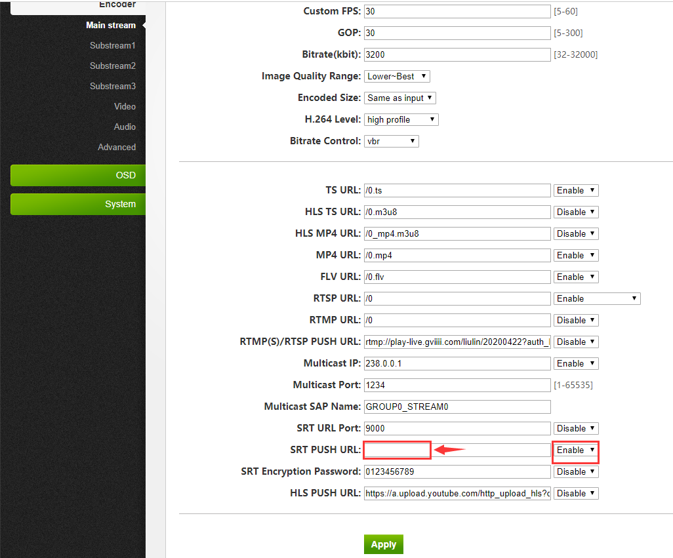

2. Status→Main stream→Whether the SRT PUSH URL is connected.

**Reboot**

System→Reboot→Click Reboot.

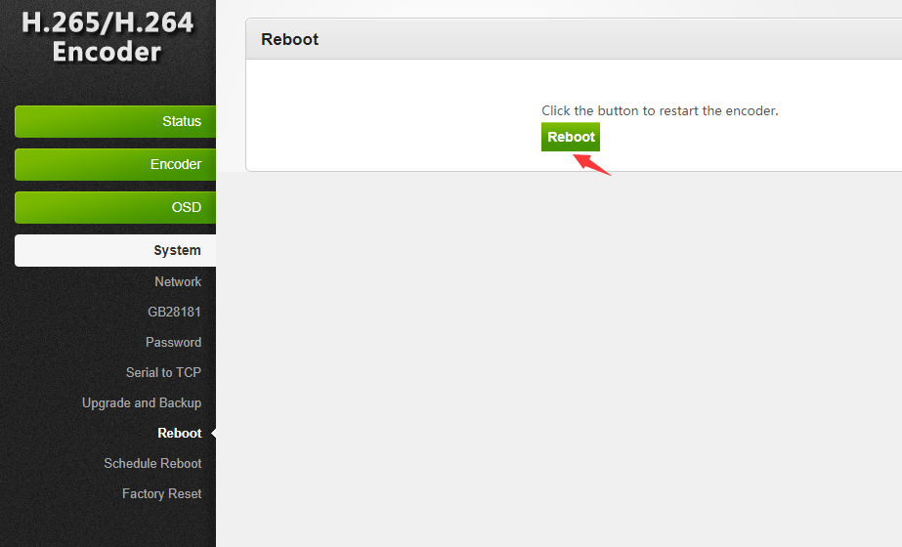

**Reset**

Choose one of the two methods

1. System→Reset→Click Reset.

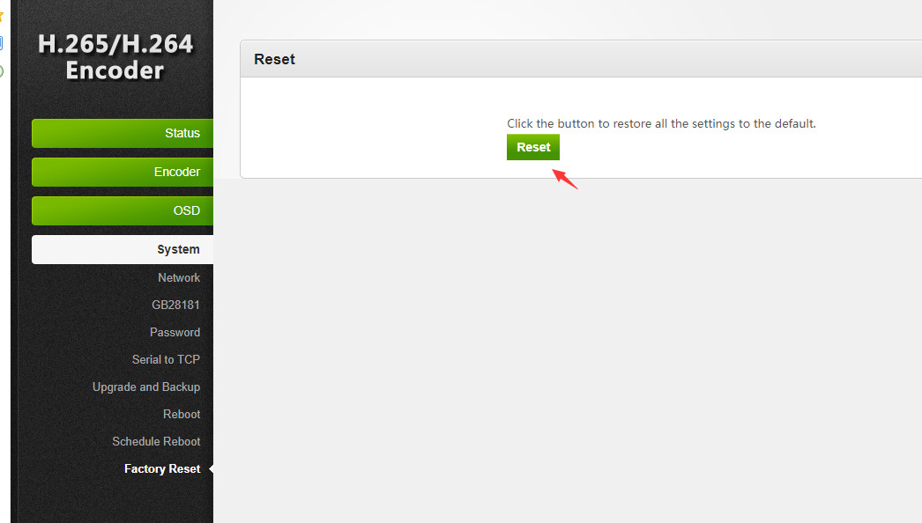

2. During operation, press and hold the reset key for more than 8 seconds until the panel indicator is off.

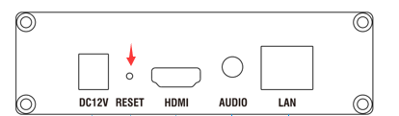

**common problem**

1. If the encoder has no signal, check whether the video source is connected to the video signal input port of the encoder.

Connect the video source to the monitor to see if there is any signal output.

2. Encoder can't live, please check whether the push address, gateway and DNS configuration are correct.

Whether it is connected to the router or switch that can access the Internet.。

3. Explanation of some parameters

FPS:How many pictures are output per second；

GOP:How many frames apart there is a key frame.

H.264 Level: encoding complexity.

Bitrate Control: CBR: Screen changes always keep fixed network data.

VBR: According to the needs of the screen to change the network traffic.

Bitrate(kbit):Network traffic per second，The following table is for reference.

|  |  |  |  |  |  |  |  |
| --- | --- | --- | --- | --- | --- | --- | --- |
| **Project** | **Formula** | **192X144** | **320X240** | **480X360** | **640X480** | **1280X720** | **1920X1080** |
| Lower bit rate | (width*high*3)/4 | 30kb/s | 60kb/s | 120kb/s | 250kb/s | 500kb/s | 1mb/s |
| Low bit rate | (width*high*3)/2 | 60kb/s | 120kb/s | 250kb/s | 500kb/s | 1mb/s | 2mb/s |
| Medium bit rate | (width*high*3） | 120kb/s | 250kb/s | 500kb/s | 1mb/s | 2mb/s | 4mb/s |
| High bit rate | (width*high*3)X2 | 250kb/s | 500kb/s | 1mb/s | 2mb/s | 4mb/s | 8mb/s |
| Higher bit rate | (width*high*3)X4 | 500kb/s | 1mb/s | 2mb/s | 4mb/s | 8mb/s | 16mb/s |